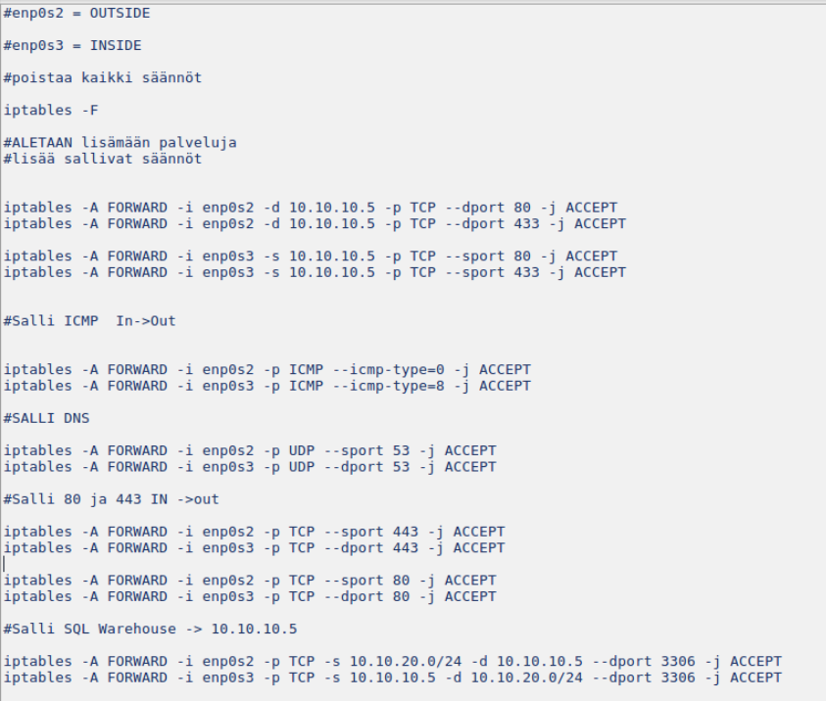

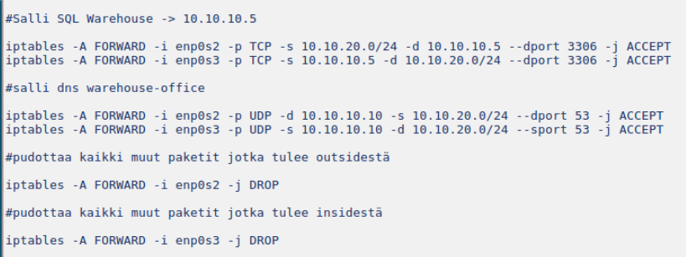

Stateless firewall
#eth0 = OUTSIDE
#eth1 = INSIDE

#removes all rules
iptables -F

#Allow http ja https outside

iptables -A FORWARD -i eth0 -d 10.10.10.5 -p TCP --dport 80 -j ACCEPT
iptables -A FORWARD -i eth0 -d 10.10.10.5 -p TCP --dport 443 -j ACCEPT

#Allow return of http
iptables -A FORWARD -i eth1 -s 10.10.10.5 -p TCP --sport 80 -j ACCEPT
iptables -A FORWARD -i eth1 -s 10.10.10.5 -p TCP --sport 443 -j ACCEPT

#allow DNS in -> out
iptables -A FORWARD -i eth1 -p UDP --dport 53 -j ACCEPT

#allow dns return out -> inside
iptables -A FORWARD -i eth0 -p UDP --sport 53 -j ACCEPT

#ALLOW web browsing in -> out
iptables -A FORWARD -i eth1 -s 10.10.10.0/24 -p TCP --dport 80 -j ACCEPT
iptables -A FORWARD -i eth1 -s 10.10.10.0/24 -p TCP --dport 443 -j ACCEPT

#ALLOW web browsing out -> in
iptables -A FORWARD -i eth0 -d 10.10.10.0/24 -p TCP --sport 80 -j ACCEPT
iptables -A FORWARD -i eth0 -d 10.10.10.0/24 -p TCP --sport 443 -j ACCEPT

#Allow ICMP In->OUT
iptables -A FORWARD -i eth0 -p ICMP --icmp-type=0 -j ACCEPT
iptables -A FORWARD -i eth1 -p ICMP --icmp-type=8 -j ACCEPT

#Allow Mysql accessible from Warehouse

iptables -A FORWARD -i eth1 -p TCP -d 10.10.20.0/24 -s 10.10.10.0/24 --sport 3306 -j ACCEPT
iptables -A FORWARD -i eth0 -p TCP -d 10.10.10.0/24 -s 10.10.20.0/24 --dport 3306 -j ACCEPT

#ALLOW Access to webstore
#out->in
iptables -A FORWARD -i eth1 -d 10.10.20.0/24 -s 10.10.10.10 -p TCP --sport 80 -j ACCEPT
#in->out
iptables -A FORWARD -i eth0 -d 10.10.10.10 -s 10.10.20.0/24 -p TCP --dport 80 -j ACCEPT

#Allow internal dns
iptables -A FORWARD -i eth1 -d 10.10.20.0/24 -s 10.10.10.10 -p UDP --sport 53 -j ACCEPT

iptables -A FORWARD -i eth0 -d 10.10.10.10 -s 10.10.20.0/24 -p UDP --dport 53 -j ACCEPT

#Drop all packet coming from outside
iptables -A FORWARD -i eth0 -j DROP

#Drop all packet coming from inside
iptables -A FORWARD -i eth1 -j DROP

